Jasmine Granot 308120559 Yasminso@mta.ac.il

Vered Harel 205680523 Veredha@mta.ac.il

**System Description:**

Our M.A.Git System is divided to several screens in order to make it easier on the user:

1. **Login Screen:**

On this screen, user will enter a username.

At the first login, a new account will be created for the user.

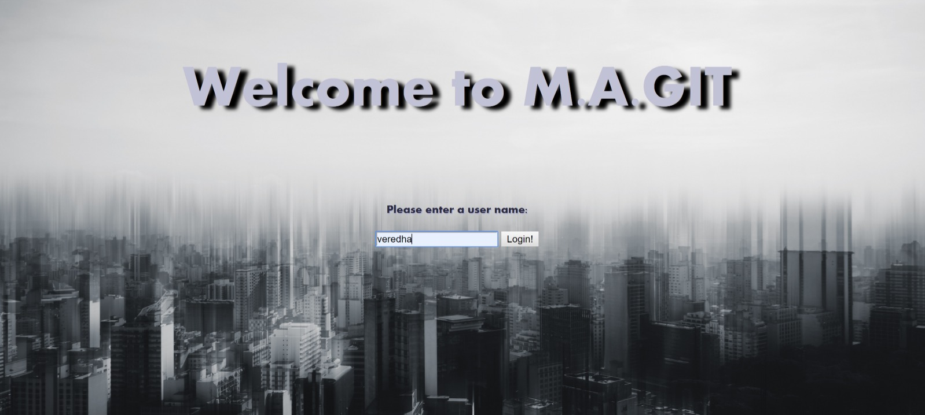

Known issues:

* 1. If user's already logged in at another session, login will redirect to login page, without showing any errors.

1. **Main User Screen:**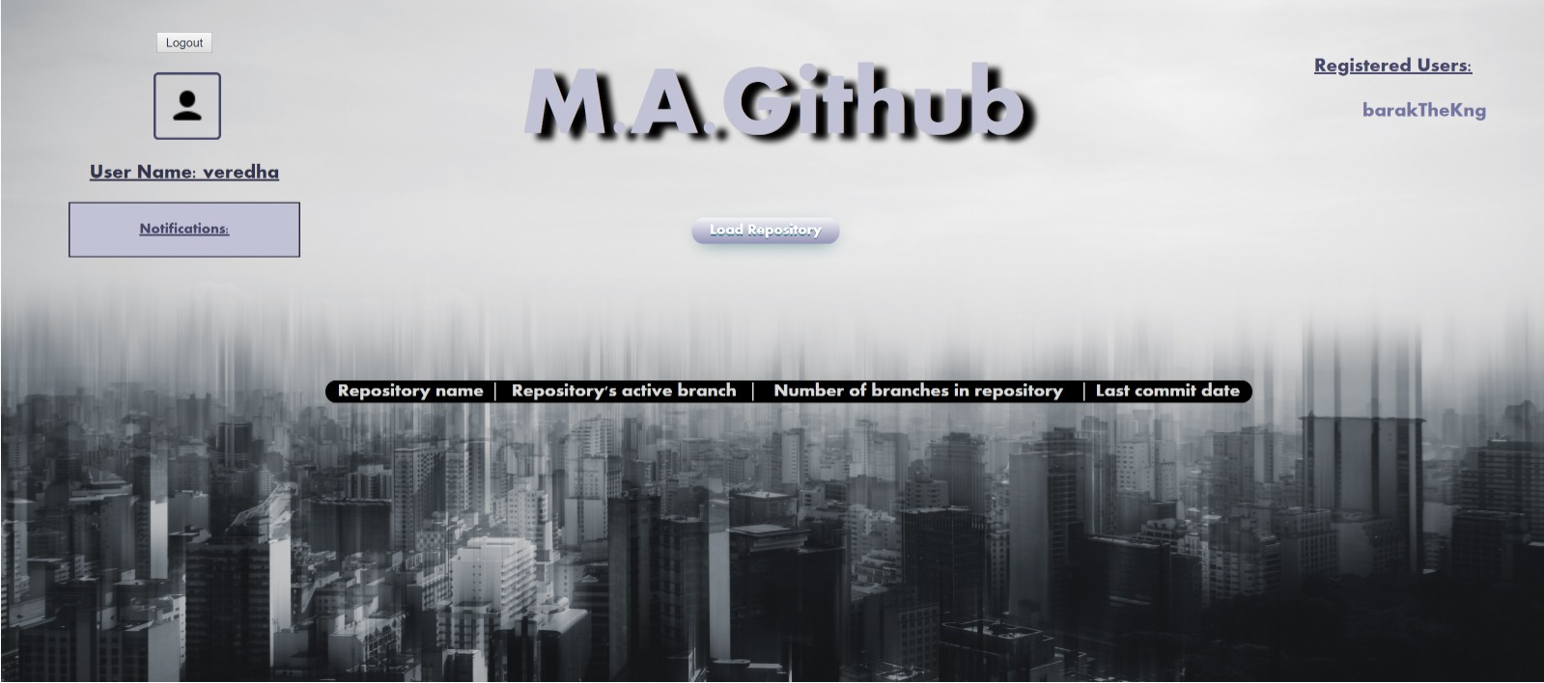

User can see his own repository, load repository from XML, and see notifications from other users and logout. In addition, on the right, all active users are shown.   
Clicking on a username (**including the current user's name on the left of screen**) will show his repositories (with an option to fork)**.**

Clicking on "Go To Repository" will redirect the user to see the repository with full details.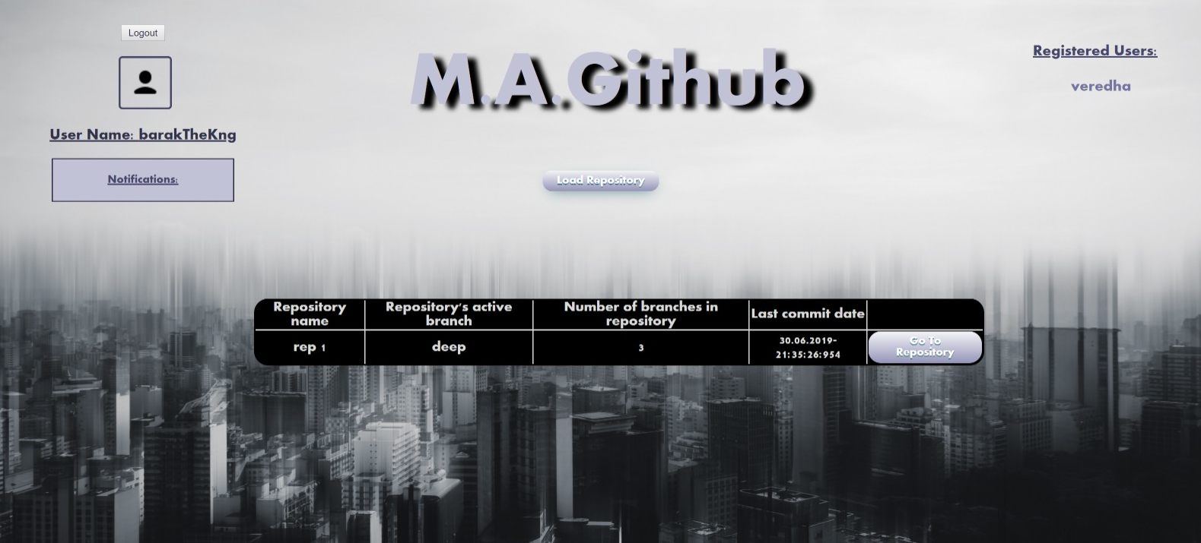(barakTheKing is looking at his own repositories)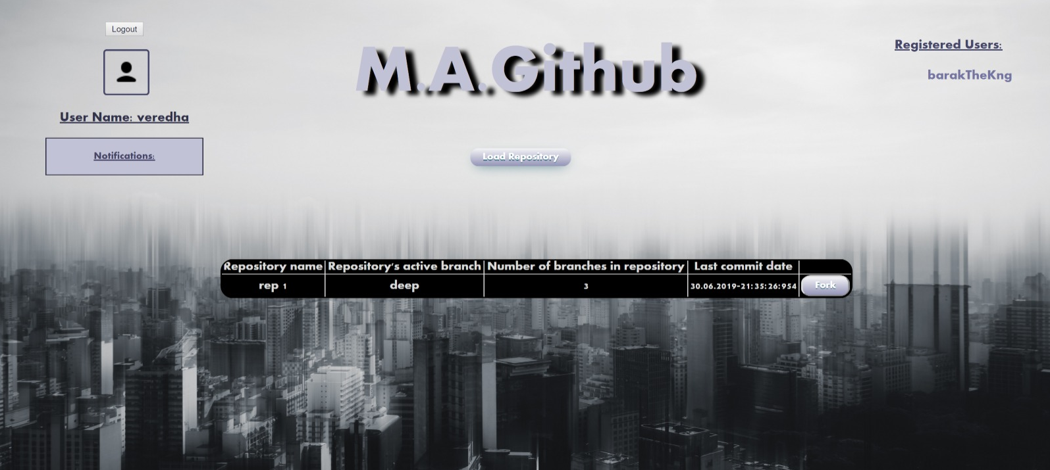(veredha is looking at barakTheKing's repositories)

Known Issues:

1. All lists (notifications + registered users) are align to the left even though we really tried!
2. Resizing does not fully functioning (cuts a bit of the active user's list).
3. Loading repository from XML requires clicking on the button itself, though for some unknown reason the all area is "clickable".
4. Loading repository from XML requires changing the file. Button is defined as "on change" and not "on click". Sorry!
5. **Repository Screen:**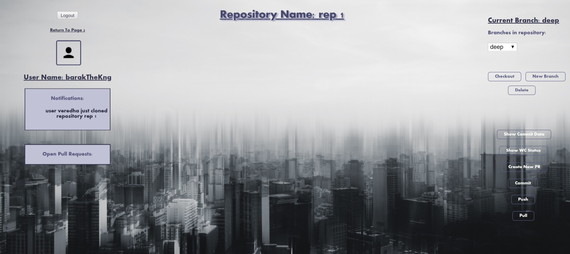

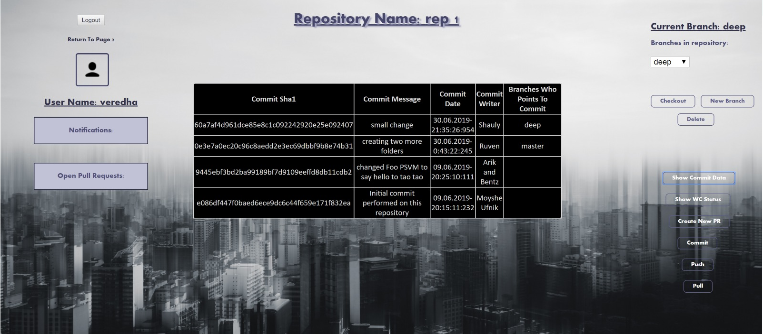

On this screen, a user can logout (data will reload when user logs in again), return to main user's screen, commit, and if repository was forked, open pull requests of the repository, push and pull. In addition, user can:

1. Watch notification – a click on a notification will open it as alert, and then the notification will disappear.
2. Open pull request – a click on a pull request will open a new popup window with the pull request's full information. See Pull Request Screen for more information.
3. Create new branch – a branch name cannot contain spaces. A commit can be provided but not a must. If no commit was provided, head commit will be taken.
4. Checkout – choose a branch from drop-down list and press checkout.
5. Delete branch – choose a branch from drop-down list and press delete. Head branch cannot be deleted. If the branch is tracking a remote branch, both will be deleted. **BONUS**
6. Show commit data – will show the current head branch commit history, with all branches currently pointing to these commits.
7. Create a new Pull request – requires 2 branches to merge and a message. A notification will be sent to the remote repository's owner.
8. Show WC Status – (require double click when not in incognito – known but not an issue) will open a popup with all current working copy data and actions. For more information, see WC Status Screen.

Known Issues:

1. Resizing cuts a bit of the screen, sorry.
2. All lists (notifications + open pull requests) are aligned to the left (same issue as Main User Screen).
3. The commit list is not resizable at all for unknown reasons (We lost the war…).
4. **Pull Request Screen:** 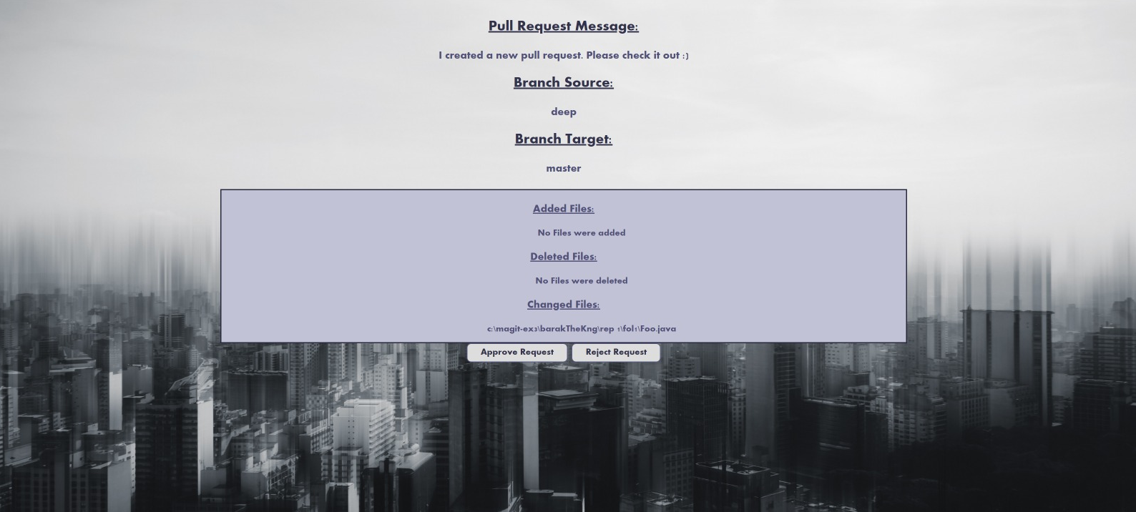User can approve/reject the pull request.

In case of rejecting, the user will need to add a message for the pull request's owner.

**Bonus – the changed files between the branches to merge are aggregated.**

Known Issues:

1. The files in the delta are aligned to the left for unknown reason.
2. Since this is a popup, popup blocker must be deactivated.
3. **WC Status Screen**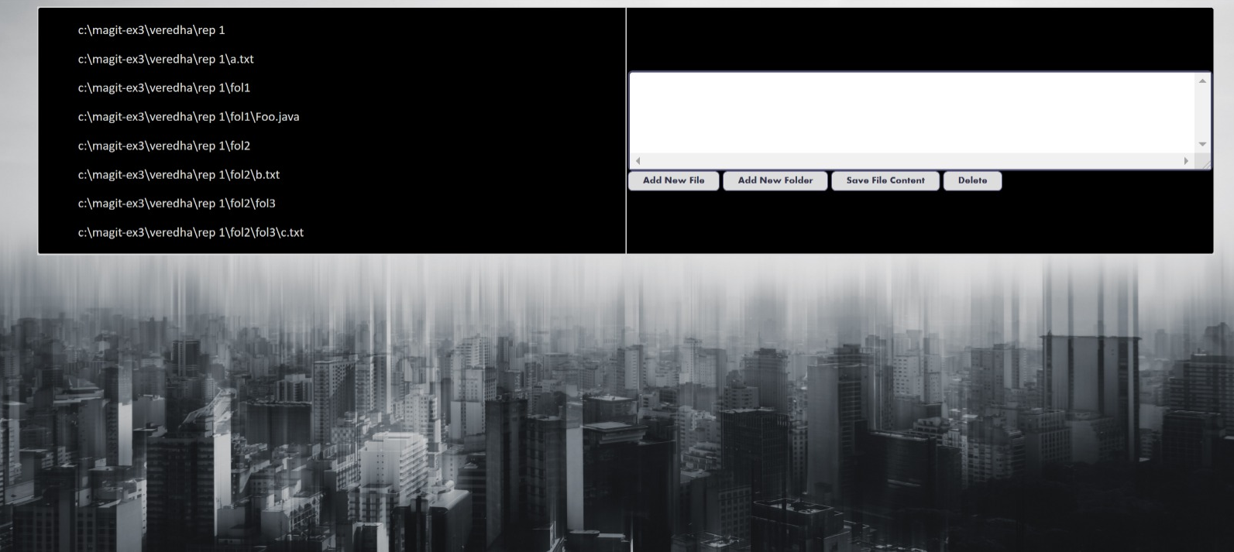User can see the current files In the System.

User can:

1. Edit file – when choosing a file (not a folder!) the file path will change to bold red, and the content will be shown. User can edit and save by clicking the save button.
2. Delete a file/folder – When choosing a file/folder (the file path will change to bold red) user can press the delete button. Main repository's folder cannot be deleted.
3. Add a file/ folder – When choosing a folder (not a file), the file path will change to bold red.  
   Pressing the 'Add New File' or 'Add New Folder' and then entering the name will create the file/folder. Assuming Folder is only created in order to create files in it (as we do not support empty folders).

Known Issues:

1. When switching paths without doing an action in between, both are marked as selected though only the last one is truly selected.

**General Notes**

System architecture:

1. Engine – Same as ex.2, main difference is that 'Repository' in ex.3 is an object rather than a class as in ex.2.
2. Web –
   1. Servlets –
      1. Index Direct – The servlet redirects the index.html page to the system's login page.
      2. Login Servlet – Handles the login page. If user's already logged in at another session will redirect the login page.
      3. Logout Servlet – Handles the logout button in page 2 and 3. Logout will safely remove the user from the session (will not delete its information in the c:\magit-ex3 file!).
      4. System Servlet – Creates the c:\magit-ex3 folder at the beginning of the program, and deletes it in the end.
      5. Page 2 Servlets –
         1. Load XML Servlet – Handles the xml upload button.
         2. Fork Repository Servlet – Handles the fork button.
      6. Page 3 Servlets –
         1. Repo Actions Servlet – Handles page 3 buttons and options.
         2. Refresh Data Servlet – Maintains the data in page 3 to its updated version (notifications, pull requests, branches etc.).
         3. Page 3 Servlet – Updates the current repository in the session.
      7. New Tab Servlets –
         1. Files Modifying Servlets – Handles the Show WC Status button, and the content on the show WC status popup window.
         2. Pull Request Servlet – Handles the Pull request popup window, its content and buttons.
   2. Pages – for each page in the system there is a destined folder which contains the html file, css file and the java-script file.

Known Issues:

1. Resizing in general is a problem, we do not know why.
2. Sometimes for unknown reasons, there is a 500 error on the web (loading resources), in case it happens, please restart and don't fail us.
3. Popups Requires popup blocker deactivation on chrome, but it was so cool we could not give up on it.
4. Notifications are taken only from last sign out time.

**We fought this war until the vary end, hope you'll enjoy (A bonus for the UI should be in considered) ☺**